Module 3: Advnaced Sql

Exercise 1:Ranking and window functions
ROW_NUMBER():
Assigns a unique sequential number to each row within a partition.
RANK():
Assigns the same rank to tied values and skips subsequent ranks.
DENSE_RANK():
Assigns the same rank to tied values but does not skip ranks.
PARTITION BY:
Divides rows into groups before applying ranking functions.
OVER():
Defines the window or set of rows on which the function operates
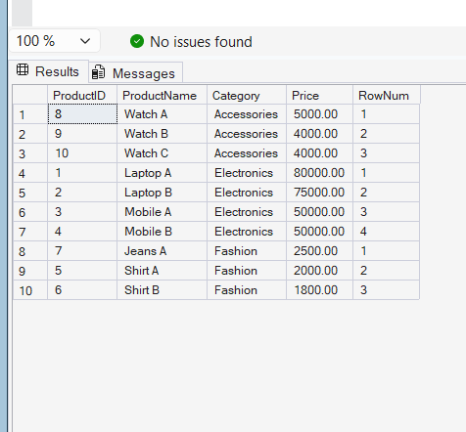# Output..

4-Exercise:Stored Procedure
#OUTPUT
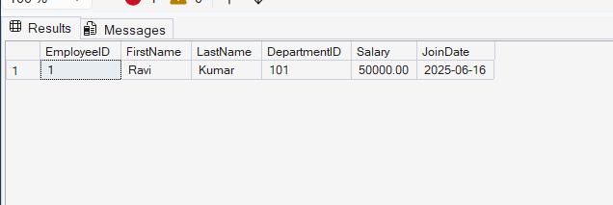
Theory
What is a Stored Procedure?
A Stored Procedure is a collection of SQL statements stored in the database that can be executed whenever required. It helps in performing database operations efficiently and repeatedly without writing the same SQL code multiple times.
Purpose of Stored Procedures
- Improve code reusability.
- Increase performance through precompiled execution plans.
- Enhance security by controlling database access.
- Simplify database maintenance.
- Reduce code duplication.
Procedure Used
In this exercise, a stored procedure named sp_InsertEmployee was created to insert employee details into the Employees table.
The procedure accepts the following parameters:
- FirstName
- LastName
- DepartmentID
- Salary
- JoinDate
When executed, it inserts a new employee record into the Employees table.
Advantages of Stored Procedures
- Faster execution compared to repeated SQL queries.
- Reusable and modular code.
- Better security and access control.
- Easier maintenance and updates.
- Reduced network traffic between application and database.

Exercise5_ReturnDataFromStoredProcedure
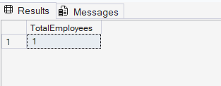#Output
A Stored Procedure is a set of SQL statements stored in the database that can be executed whenever required. It helps improve performance, code reusability, and database security.
In this exercise, a stored procedure named sp_GetEmployeeCountByDepartment was created. The procedure accepts DepartmentID as an input parameter and returns the total number of employees working in that department using the COUNT() function.
The procedure was executed by passing a DepartmentID value, and the result displayed the total employee count for the specified department.
Advantages
- Improves code reusability.
- Enhances database performance.
- Reduces repetitive SQL code.
- Makes data retrieval easier and more efficient.
Conclusion
The stored procedure successfully returned the total number of employees in a specified department using a parameterized query and the COUNT() aggregate function.

